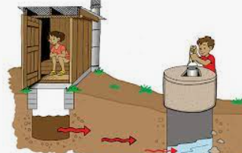
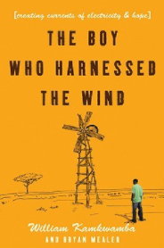
Year 5’s learning this half term:

English:
William Kamkwamba’s ‘The Boy Who Harnessed The Wind’ is this half term’s
core text and is a book to bring awareness about sustainable development
and awareness of the need for clean water. The story follows the main
character’s journey in creating a renewable energy source that can
provide electricity for his family and his village. The children will be using persuasive language as well as key information from the text as their basis for their own writing skills. By the end of this half term, the children will have created their own descriptive narrative of Williams successful journey.

Maths:
In Maths this half term, the focus will be on using efficient methods to multiply and divide numbers, which will include dividing with remainders. The children will explore mathematical concepts within live contexts. Following on from this, Year 5 will be exploring money calculations, including creating a budget. This will be done using concrete, abstract and pictorial methods.

Science:
This half term in Science, Year 5 will be learning about waterborne diseases. They will be exploring the diseases that can be caused by water and the impact that they can have on us as humans. They will also be investigating ways in which we can make our water clean and using secondary sources such as PH scales and planning and conducting their own experiments with water. ​

PE:
This half term in PE, Year 5 will be focusing on dance and co-operative learning. The children will be learning about how to create movements that tell a story and how to communicate in a variety of ways in non-contact games They will be using a range of different strategies to improve their coordination.

RSE:
Our RSE focus this half term will be linked to our core text and the subject of ‘community and relationships’; the children will be working on conflict resolution skills as well as looking at what makes a good friend.

Welcome Back!
You can follow our class twitter pages to keep up to date with what is happening in the classroom @Y5beechWoodhill, @Y5Willow and @Year5PalmTree

If you would like to contact your class teacher, please do not hesitate to make a telephone appointment through the school office or email us at togundarealli@woodhill.greenwich.sch.uk, tlategan@woodhill.greenwich.sch.uk and lday@woodhill.greenwich.sch.uk
School value:
Our school value for this half term is Kindness. Circle time sessions will give the children the chance to explore our value.
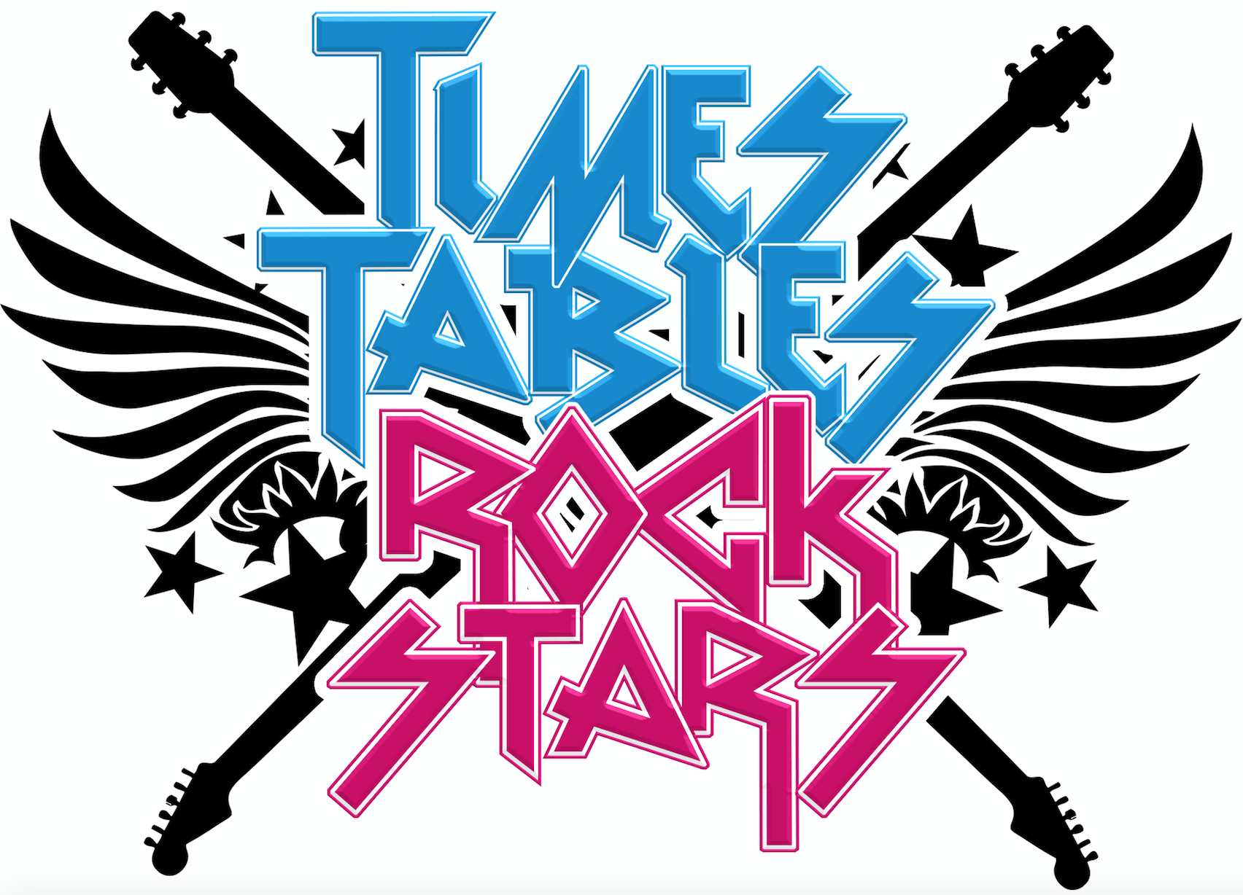
Dates for the Diary:
Friday 5th November –National British Museum
Thursday 11th November- Remembrance Day
Wednesday 24th November – Local church visit
Friday 26th November- Inset day
Tuesday 14th December- Winter Concert
16th December- Christmas Holiday
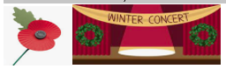

Reading
We do whole class reading every day. The children will work as a whole class, reading a range of texts that will help extend their literary understanding.
The children will change their home reading books once they have finished and returned their book. Children will choose a book of free choice to enjoy at home as well as having to bring it into class each day.
Please try to read with your child every day at home for twenty minutes. Please feel free to give feedback about how they got on, or the difficulty level of the reading book in their Reading Records.

General Information
PE: PE will take place twice a week on Wednesday and Friday for Year 5. Children should bring their PE kits to school on these days. These PE lessons will all be outside. Please ensure your child has warm kit for this including sensible shoes, trousers/joggers and a jumper.
Reading journals: Please ensure children bring in their reading journals to school every day. This allows teachers to check when children have achieved a book certificate and see how they’re progressing with their home reading.
Water bottles: Please ensure your child brings a clean, suitable water bottle, filled with water, into class with their name on.
Times Tables: In Year 5, children will continue practising instant recall of their times table. This half term, children will focus on learning the 3 and 6 times tables.
Music:
In Music, the children will be working towards creating and performing their own musical piece. They will learn create rhythms using a base and experimenting with African musical instruments.

Curriculum:
In Curriculum, the children will be exploring historical events and the impact Ethiopia’s climate. They will be researching the country’s socio- economic background, whilst understanding its locality in Africa. This term they will focus on renewable energy and make connections between human geography and sustainability. By the end of the term they would have learnt the skills needed to become young entrepreneurs.

Art:
This half term Year 5 will be taking inspiration from Theo Jansen’s art sculptures. The children will begin the unit by creating their own sketches based on Jansen’s work. They will also be exploring materials while planning and designing their own sculptures that are linked to their core text ‘The Boy Who Harnessed The Wind’. Their final outcome will be to create a model windmill using recyclable material.

French: Children will start the term with plenty of opportunity to recap key language from prior learning. The children will then move on to learning about seasons and the months of the year. By the end of the unit, children will be able to give descriptions and hold conversations confidently.

