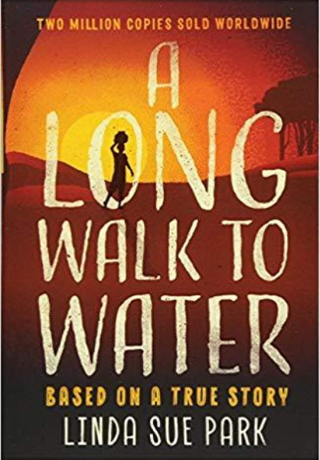
Year 5’s learning this half term:

English:
Linda Sue Park’s A Long Walk to Water is this half term’s core text and is a book to bring awareness about sustainable enterprise. The story follows the main characters hardships and their journey that occurs in the same place but in different timelines. The children will be using emotive language as well as innovative ideas from text as their basis for their own writing skills. By the end of this half term, the children will have created their own biograph based on the life of Salva Dut.

Maths:
In Maths this half term, our focus will be on place value and ordering numbers including decimals. The children will explore mathematical concepts within live contexts. Following on from this, year 5 will be finding fractions of an amount as well as converting improper fractions to mixed numbers. This will be done using concrete, abstract and pictorial methods.

Science:
This half term in Science, Year 5 will be learning about States of Matter. They will be describing the properties of materials in different forms before exploring its sources and explaining how they differ. There will be lots of experiments including test on the best materials to use for a survival kit. They will be using scientific language when writing up an accurate fair test based on a scientific enquiry.

PE:
This half term in PE, Year 5 will be focusing on gymnastics and multi- skill games. The children will be learning about how to build tension in their muscles and how to use their balance to hold a static pose. They will be using a range of different strategies to improve their agility during activities.

RSE:
Our RSE focus this half term will be linked to our core text and the subject of ‘family and identity’; the children will be discussing what makes them feel like they belong and the traits that make them different and giving them their identity.

Welcome Back!
You can follow our class twitter pages to keep up to date with what is happening in the classroom @Y5beechWoodhill, @Y5Willow and @Year5PalmTree

If you would like to contact your class teacher, please do not hesitate to make a telephone appointment through the school office or email us at togundarealli@woodhill.greenwich.sch.uk, tlategan@woodhill.greenwich.sch.uk and lday@woodhill.greenwich.sch.uk
School value:
Our school value for this half term is Kindness. Circle time sessions will give the children the chance to explore our value.
Reading
We do whole class reading every day. The children will work as a whole class, reading a range of texts that will help extend their literary understanding.
The children will change their home reading books once they have finished and returned their book. Children will choose a book of free choice to enjoy at home as well as having to bring it into class each day.
Please try to read with your child every day at home for twenty minutes. Please feel free to give feedback about how they got on, or the difficulty level of the reading book in their Reading Records. We appreciate all parental feedback.

It has been so lovely to see so many children reading with parents at home and earning their reading certificates. Please continue to read at home with your child. We are keeping track of how many books each child reads as part of the Reading Challenge total.
Dates for the Diary:
Monday 13th September – Meet the teacher videos shared
Friday 22nd October - Last day of term
Monday 1st November – Autumn 2 term begins
General Information
PE: PE will take place twice a week on Wednesday and Friday for Year 5. Children should bring their PE kits to school on these days. These PE lessons will all be outside. Please ensure your child has warm kit for this including sensible shoes, trousers/joggers and a jumper.
Reading journals: Please ensure children bring in their reading journals to school every day. This allows teachers to check when children have achieved a book certificate and see how they’re progressing with their home reading.
Water bottles: Please ensure your child brings a clean, suitable water bottle, filled with water, into class with their name on.
Times Tables: In Year 5, children will continue practising instant recall of their times table. This half term, children will focus on learning the 8 times tables.
Music:
In Music, the children will be working towards creating and performing their own musical piece. They will learn to describe music using the correct vocabulary, as well as explore various musical instruments.

Curriculum:
In Curriculum, the children will be exploring historical events and the impact on modern Britain. They will be researching the Anglo-Saxon economy, whilst comparing and contrasting two localities. This term we will focus on water sustainability and make connections between human geography and sustainability. By the end of the term they would have learnt the skills needed to become young entrepreneurs.

Art:
This half term the artist Cherie Roe Dirksen acts as the inspiration for our Art work. The children will begin the unit exploring the themes and moods consistent with traditional African sunsets. Once familiar with a range of her work, children will then compare it to the illustrations from our core text, A Long Walk to Water. They will spend time practising techniques using various mediums and evaluate which works best for their final outcome – a sunset canvas.

French: Children will start the year with plenty of opportunity to recap key language from prior learning. The children will then move on to learning about greeting people and holding simple conversations. By the end of the unit, children will be able to give descriptions and hold conversations confidently.

