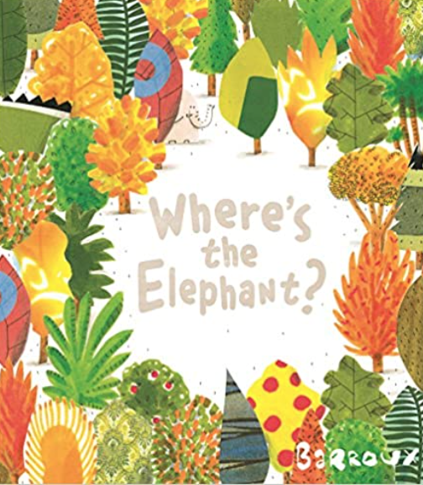

Year R’s learning this half term:

(curriculum-global theme overview, including English outcomes)
Our learning for this half term is focused around sustainable
development and the book ‘Where’s the Elephant?’ by Barroux.

Physical, Social and Emotional Development
We will be practising taking turns and sharing our resources. We will also be learning how to listen carefully to our friends and talking to find a solution to problems. At home you can support by talking to me about my friendships and encourage me to listen to others’ feelings and ideas. You can also help me to express how I am feeling and ways I can independently solve problems.

Communication and Language
We will be listening carefully to each other, asking questions and giving our opinion. We will be building up our vocabulary, particularly around the theme of sustainable development and using these new words to express our ideas. At home you can encourage me to talk to friends and family about the things I have learnt, seen or heard.

Physical Development
We will be developing our physical skills through play. We will develop our fine motor control by using tools such as scissors, tweezers and pencils to practise little movements. We will be using our bodies to move around outside, through activities such as completing an obstacle course to develop our gross motor control.
Literacy
We will be looking at retelling and ordering the events in the story ‘Where’s the Elephant?’ by Barroux using story mountains. We will use story mountains to reflect on how the characters’ emotions change and develop throughout the story. We will be role playing as the characters to help identify their emotions. We will then use our sounds and sentence toolkits to write speech bubbles in role as the characters. We will later use our research and knowledge of endangered animals to write our own stories.
Happy New Year
Happy New Year and a very warm welcome back to our Reception children and their families. We are looking forward to the new term and immersing ourselves in our new learning.
If you wish to speak to Miss Doan or Miss Jackson please book an appointment with the school office, 020 8854 5055, or you can contact us directly, via email at, Miss Doan (Saplings Class) adoan@woodhill.greenwich.sch.uk
Miss Jackson (Acorns Class) zjackson@woodhill.greenwich.sch.uk
General Information
Water bottles: Please ensure your child brings a clean, suitable water bottle into class with their name on.
Lost property: To ensure that personal items are not lost, please write your child’s name on their book bag and all of clothing. You can purchase labels from the Woodhill Primary School Office.
All weather: Children have access to the outdoors in all weathers. Please ensure that they come dressed appropriately for the day (e.g. coat, hat, gloves, wellies, etc.) Please provide a bag with a spare change of clothes in case of any accidents.
Twitter accounts:
Acorn’s Class: @EYFSAcorns Saplings Class: @EYFSSaplings

Homework
Each day you and your child should practise:
- Sharing a book for 10 minutes.
- Counting forwards and backwards to 10.
- Writing their name using an upper-case letter only at the beginning.
- Holding a conversation to share something they enjoyed about their learning each day.
Reading
The children will change their home reading books on Monday. Please ensure that your child brings a bag with their updated reading record and books to school on this day.
We ask that you try to read with your child every day at home for ten minutes. Please share feedback with us about how they got on, or the difficulty level of the reading book. We appreciate all parental feedback.

Maths
We will be learning to add and subtract using part part whole models. We will use the language of part and whole to support our understanding of addition and subtraction. For example, “This is a part and this is a part. Altogether makes the whole.”

Understanding the World
We will be exploring different animals from around the world, investigating their habitats and diet. We will also be investigating what humans and animals need to survive. We will be learning about different environmental changes and human impact on animal habitats.

Expressive Arts and Design
We will be looking carefully at different animal features. We will look at what features are the same/different and what makes different animals easily identifiable. At home you could play a game of guess who by giving clues about different animal features.

