Welcome to Reception
We hope you had a fantastic break with your families and we are looking forward to a busy half term filled with, new learning, food and celebration.

If you wish to speak to Miss Jackson or Miss Doan please book an appointment with the school office, 020 8854 5055, or you can contact us directly, via email at,
Miss Doan (Saplings Class) adoan@woodhill.greenwich.sch.uk
Miss Jackson (Acorns Class) zjackson@woodhill.greenwich.sch.uk
Miss Mapp (Phase Leader) lmapp@woodhill.greenwich.sch.uk

Year R’s learning this half term:

Curriculum-global theme overview, including English outcomes Building on our learning about identify and diversity, children
will learn about the important role, food plays in every culture both day to day and in celebrations. Through the text, Lunch at 10 Pomegranate Street by
Felicita Sala the children will learn about different dishes from around
The world and practice following the recipes to make them.

Physical, Social and Emotional Development
We will be learning to keep an open mind and try new foods. We will practice sharing our likes and dislikes about the different food we eat. We will practice turn taking and sharing with our friends when we play. Listening and responding to their ideas and including these ideas in our play.

Communication and Language
We will be learning to listen carefully and share our knowledge, experiences and ideas with others. We will talk about what foods we like and dislike and practice asking questions about other people’s preferences. We will strengthen our listening and attention skills by listening to the Adult’s instructions so that we can follow different recipes.

Physical Development
We will develop our fine motor control so that we can write. Using tools such as scissors, tweezers and pencils to strengthen our hands and practise little movements. We will be learning about the healthy diets and the important role food plays in keeping us healthy and strong.
Literacy
We will enjoy a range of fiction and non-fiction books about food. As a class we will discuss aspects that are similar and different to our own and practice asking questions about the things we hear and see in the books that we read. We will use our phonics learning, linking sounds to letters, and we will focus on using our sounds for writing words and simple sentences.

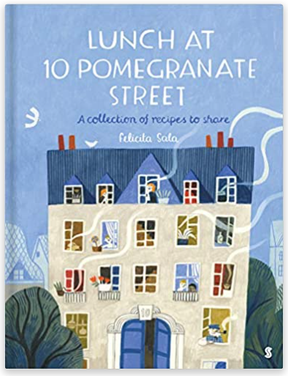

Dates for the Diary:

Friday 19th November- Children in Need and Historical dress up day
Thursday 9th December- Nativity in the afternoon
Friday 10th December- Christmas jumper and dinner day
Thursday 16th December- Last day of term

Homework
Each day you and your child should practise:
- Sharing a book for 10 minutes.
- Counting forwards and backwards to 10.
- Writing their name using an upper-case letter only at the beginning.
- Holding a conversation to share something they enjoyed about their learning each day.
Reading
The children will change their home reading books on Monday. Please ensure that your child brings their updated reading record and books to school on this day.
We ask that you try to read with your child every day at home for ten minutes. Please share feedback with us about how they got on, or the difficulty level of the reading book. We appreciate all parental feedback.

It has been so lovely to see so many children reading with parents at home and earning their reading certificates. Please continue to read at home with your child. We are keeping track of how many books each child reads as part of the Reading Challenge total.

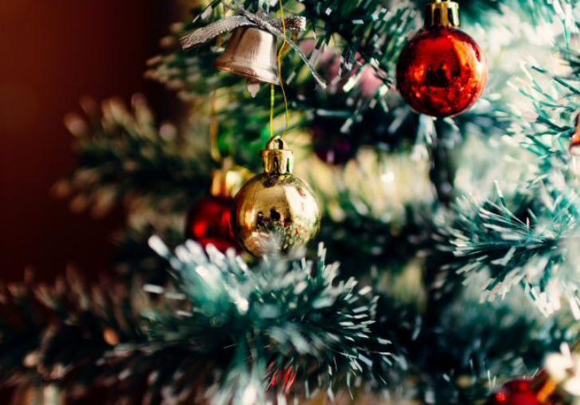
Maths
We will be learning about measurement, and how to weigh and measure food items for recipes. We will also be learning to sequence events in order from start to finish, so that we can share new recipes with one another. In Numbers, we will focus on finding numbers that are one more and one less to five before we move on to addition and subtraction.

Understanding the World
We will be exploring the world around us through our core text and
learning about different cultural celebrations like Diwali, Hanukkah,
Christmas and Kwanza.

Expressive Arts and Design
We will be exploring how food is used to make art. Focusing on works by the artist Giuseppe Arcimboldo, and using his food themed portraits to create our own.
General Information
Water bottles: Please ensure your child brings a clean, suitable water bottle into class with their name on.
Lost property: To ensure that personal items are not lost, please write your child’s name on their book bag and all of clothing. You can purchase labels from the Woodhill Primary School Office.
All weather: Children have access to the outdoors in all weathers. Please ensure that they come dressed appropriately for the day (e.g. coat, hat, gloves, wellies, etc.) Please provide a bag with a spare change of clothes in case of any accidents.
Twitter accounts:
Acorn’s Class: @EYFSAcorns Saplings Class: @EYFSSaplings

