Year R’s learning this half term:

Curriculum - Global theme overview, including English outcomes As children begin their journey in reception, they will explore their
similarities and differences and how diversity is something to be
celebrated through the text: All Are Welcome by Alexandra Penfold.
We will learn about our school’s character skills and use these skills to
support our learning around how to treat others in our school
community.

Physical, Social and Emotional Development
We will be meeting the other members of our class and sharing information about ourselves. We will be learning about how to be a positive member of the Woodhill community through our school values and character skills.

Communication and Language
We will be learning to listen carefully and share our knowledge, experiences and ideas with others. We will talk about what makes us special and practise asking questions about the things we hear and see.

Physical Development
We will be developing our physical skills through play. We will develop our fine motor control by using tools such as scissors, tweezers and pencils to practise little movements. We will be using our bodies to move around outside, through activities such as completing an obstacle course to develop our gross motor control.
Literacy
We will enjoy a range of books about people from different communities. As a class we will discuss aspects that are similar and different to our own and practise asking questions about the things we hear and see in the books that we read. We will begin to learn to read using our phonics program through linking sounds to letters, and we will focus on writing our names.
Maths
We will be learning to count reliably to 10 and recognise these numbers using Numicon to help our learning. We will also be learning to recognise numbers important to us, such as our door number or our birthday. We will be using shapes in our play to make models or patterns and learn to identify and name shapes by their properties.

Welcome to Reception
A very warm welcome to our new reception children and their families. We are looking forward to settling into our new routines and getting to know one another this term.
If you wish to speak to Miss Mapp or Miss Jackson please book an appointment with the school office: 020 8854 5055, or you can contact us directly via email at: Miss Mapp (Saplings Class) lmapp@woodhill.greenwich.sch.uk
Miss Jackson (Acorns Class) zjackson@woodhill.greenwich.sch.uk
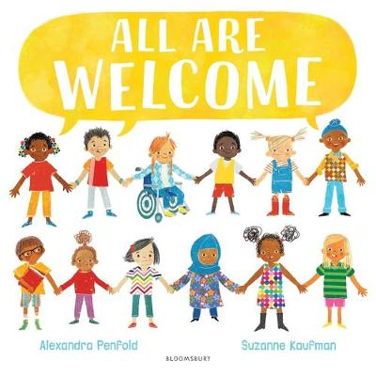

Dates for the Diary:

Meet the Teacher Monday 20th September at 3:30 in your child’s classroom
Homework
Each day you and your child should practise:
- Sharing a book for 10 minutes.
- Counting forwards and backwards to 10.
- Writing their name using an upper-case letter only at the beginning.
- Holding a conversation to share something they enjoyed about their learning each day.
Reading
The children will change their home reading books on Monday. Please ensure that your child brings a bag with their updated reading record and books to school on this day.
We ask that you try to read with your child every day at home for ten minutes. Please share feedback with us about how they got on, or the difficulty level of the reading book. We appreciate all parental feedback.

It has been so lovely to see so many children reading with parents at home and earning their reading certificates. Please continue to read at home with your child. We are keeping track of how many books each child reads as part of the Reading Challenge total.
General Information
Water bottles: Please ensure your child brings a clean, suitable water bottle into class with their name on.
Lost property: To ensure that personal items are not lost, please write your child’s name on their book bag and all clothing. You can purchase labels from the Woodhill Primary School Office.
All weather: Children have access to the outdoors in all weathers. Please ensure that they come dressed appropriately for the day (e.g. coat, hat, gloves, wellies, etc.) Please provide a bag with a spare change of clothes in case of any accidents.
Twitter accounts:
Acorn’s Class: @EYFSAcorns
Saplings Class: @EYFSSaplings
Woodhill EYFS: @WoodhillEYFS

Over the coming weeks the children will complete statutory baseline assessments to find out what they have already learnt. The assessments will be practical tasks planned and resourced through our classroom provision. You can find more information by clicking the link below. https://assets.publishing.service.gov.uk/government/uploads/system/uploads/attachment_data/file/1004560/2021_Information_for_parents_reception_baseline_assessment.pdf

Understanding the World
We will be exploring the world around us through our core text and learning about our community. We will be creating a class map to celebrate our diversity and sharing ways to say hello in different languages.

Expressive Arts and Design
We will be looking carefully at our faces and creating self-portraits using a variety of materials to create our own self-portraits including collage, transient art and line drawings.

