Monday 1st September 2025

Dear Parents/Carers,

Re: Year 6 to Year 7 transition

We are writing to inform you that your child will be due to start secondary school in September 2026.

The secondary admissions booklet for 2026/27 is now available on the Greenwich admissions website, please click on the link below to view. https://edition.pagesuite-professional.co.uk/html5/reader/production/default.aspx?pubname=&pubid=544b8783-16f8-47e1-aa52-9701795c26c5

Some of the open events begin as early as this weekend so please do make the time to look
through the information and decide on which schools you are going to visit with your child. Please
make sure you inform the school should your child be on a visit for part of the day, as we can then
insert the correct code on the register so it does not affect their attendance.

With the secondary transfer process in mind; we would like to invite you to a short meeting on Tuesday 9th September at either 9:15am or 4.00pm, these will be held in the main hall (You only need to come to one of these meetings).

These sessions will provide all the key dates involved in the process, how to apply as well as giving you the opportunity to ask any questions you may have.

If you are unable to attend one of these sessions, please email Sarah White on info@inspirewoodhill.co.uk who will be happy to help you.

To portal is open now to complete your admission form, please visit https://www.eadmissions.org.uk/
The deadline for applications is midnight on 31st October 2025.

If you need support in completing the admission form, please contact the school office to book an appointment.

With best regards,
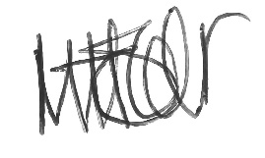
Martha Holder
Headteacher

